IEC 15408 (The Common Criteria for Information Technology Security Evaluation)
- Also referred to as Common Criteria or CC) is an international standard (ISO/IEC 15408) for computer security certification.
- Current version 3.1 revision 5.
- It is a framework that provides criteria for independent, scalable, and globally recognized security inspections for IT products.
- It is especially designed for products destined for highly security-intensive markets, such as governmental, banking, or military sectors.
- It is a framework where users can specify their Security functional / Assurance requirements (SFR/ SAR) in a Security target (ST) taken from a Protection profile (PP).
- Maintains a list of certified products, including operating systems, access control systems, databases, and key management systems.
- It can be applied to Operating systems, databases, network devices, smart cards.
- Certification of a specific version only applies to that version and not the newer version.

Evaluation Procedure:
- With the support of a third party contracted laboratory, we perform Common Criteria evaluations of your computer security products and systems.
- The partner laboratory must first define a target of evaluation (TOE) allowing for further assessment of current and applicable documentation.
- Upon completion of the documentation review and a thorough CC evaluation, we can provide you support and help you attain your IT product security certification.
- TOE (target of evaluation):
The product or system that is the subject of the evaluation.
It is the product to be tested.
- The evaluation must verify the security features by:

- Protection Profile: (TYPE OF PRODUCT)
- It identifies security requirements for a class of security devices (for example, smart cards used to provide digital signatures, or network firewalls) to the user.
- Description about the needed security solutions.
- PP serves as a template.
- A document created by a user/ user community.
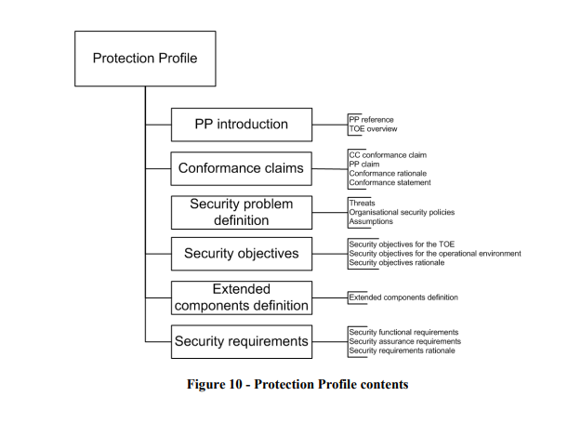

- Security Target:
- It is a document that identifies the security properties of the target of evaluation.
- Allows to make changes for the evaluation to accurately match the intended capabilities / requirements of their product.
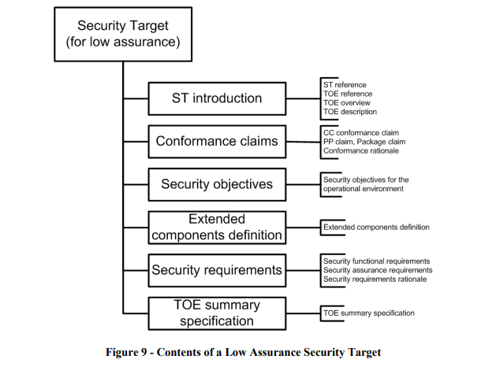

- Security Functional Requirements:
- specifies individual security functions which may be provided by a product.

Services offered by IEC 15408:
- Professional support and help with the evaluation along with certification of your product.
- Well-trained personnel with in-depth knowledge of the Common Criteria standard.
- Reliable and extensive evaluation services from an independent Certification Body.
- Tailored consultancy on IT product security and certification.

Quality Assurance processes:

- The Evaluation Assurance Level (EAL) It is the numerical rating used to describe the depth and rigor of a CC evaluation.
Each EAL is corresponded to a package of security assurance requirements for the development of the product.
There are 7 EAL’s from EAL 1-7 (low security to high security).
Evaluation Ratings
EAL 1 | Functionally tested (Black Box)
EAL 2 | Structurally tested (Black & White Box)
EAL 3 | Methodically tested and checked
EAL 4 | Methodically designed, tested, and reviewed
EAL 5 | Semi formally designed and tested
EAL 6 | Semi formally verified, designed, and tested
EAL 7 | Formally verified, designed, and tested
- The Security Assurance Requirements (SARs) describe measures taken during the development and evaluation of a safety product to ensure compliance with the claimed security functionalities.

Certificate No. | C0589
Certified Date | March 16, 2018
TOE Name | Android OS Ver. Palm Vein Authentication software
TOE Version | Ver1.00.m01
TOE Type | Biometrics Authentication Product
CC Version | 3.1r4
Conforming Assurance Requirements | EAL2 and additional assurance component ALC_FLR.1
PP Conformance | Biometric Authentication Product Protection Profile Ver.1.2(JISEC Certification No.:C0501)

REFERENCES
http://www.commoncriteriaportal.org/files/ccfiles/CCPART1V3.1R3.pdf

https://webstore.iec.ch/preview/info_isoiec15408-1%7Bed3.0%7Den.pdf

https://www.tuv.com/world/en/common-criteria-services-%E2%80%93-iso-15408.html

 | In-vitro Diagnostic Devices (IVD Devices) | Medical Devices
Regulation | EU IVDR 2017/746 | EU IVDR 2017/745
Definition | - IVDs are medical devices and accessories used in-vitro for performing tests on samples.  - such as blood, urine, tissues taken from the human body.  - to help detect infections, prevent diseases, diagnose a medical condition. | - Medical devices are instruments apparatus, appliance, material or other article and accessories to such items as intended by the manufacturer.  - used on human beings for  - diagnosis, prevention, monitoring, treatment, or alleviation of diseases,  - diagnosis, prevention, monitoring, treatment or compensation for injury or handicap,  - investigation, replacement, or modification of anatomical or physiological process  - control of conception, and that does not achieve its intended purpose.
Classification | Classes A, B, C and D | Classes I, IIa, IIb and III
Examples | - Hepatitis tests,  - HIV tests,  - Coagulation test systems,  - Pregnancy tests,  - Urine test strips,  - Blood sugar monitoring systems for diabetes patients. | - Pacemakers,  - MRI machine,  - X-ray machine,  - Ultrasound machines,  - Hip implants,  - Sutures,

